**Experiment no- 06**

Name: Suraj P. Patil

Roll No: 3034

URN: 20131086

Class: TY(A)

Batch: T-2

**Title:**

*Draw a collaboration diagram.*

A collaboration diagram in UML (Unified Modeling Language) is a type of diagram that shows the interactions and relationships among objects or actors within a system. It is also known as a communication diagram

In a collaboration diagram, the focus is on the messages exchanged between objects or actors rather than the order of events or sequence. It is useful for understanding the flow of messages between objects or actors in a system and for identifying potential issues with the system's design

The diagram consists of a set of objects or actors represented as rectangles or stick figures, respectively, and the messages exchanged between them represented as arrows. The messages can include requests, responses, and other types of communication.

Collaboration diagrams also include labels to indicate the type of message being sent, as well as any constraints or conditions that must be met for the message to be sent. Additionally, they can include lifelines, which represent the duration of an object or actor's participation in the interaction

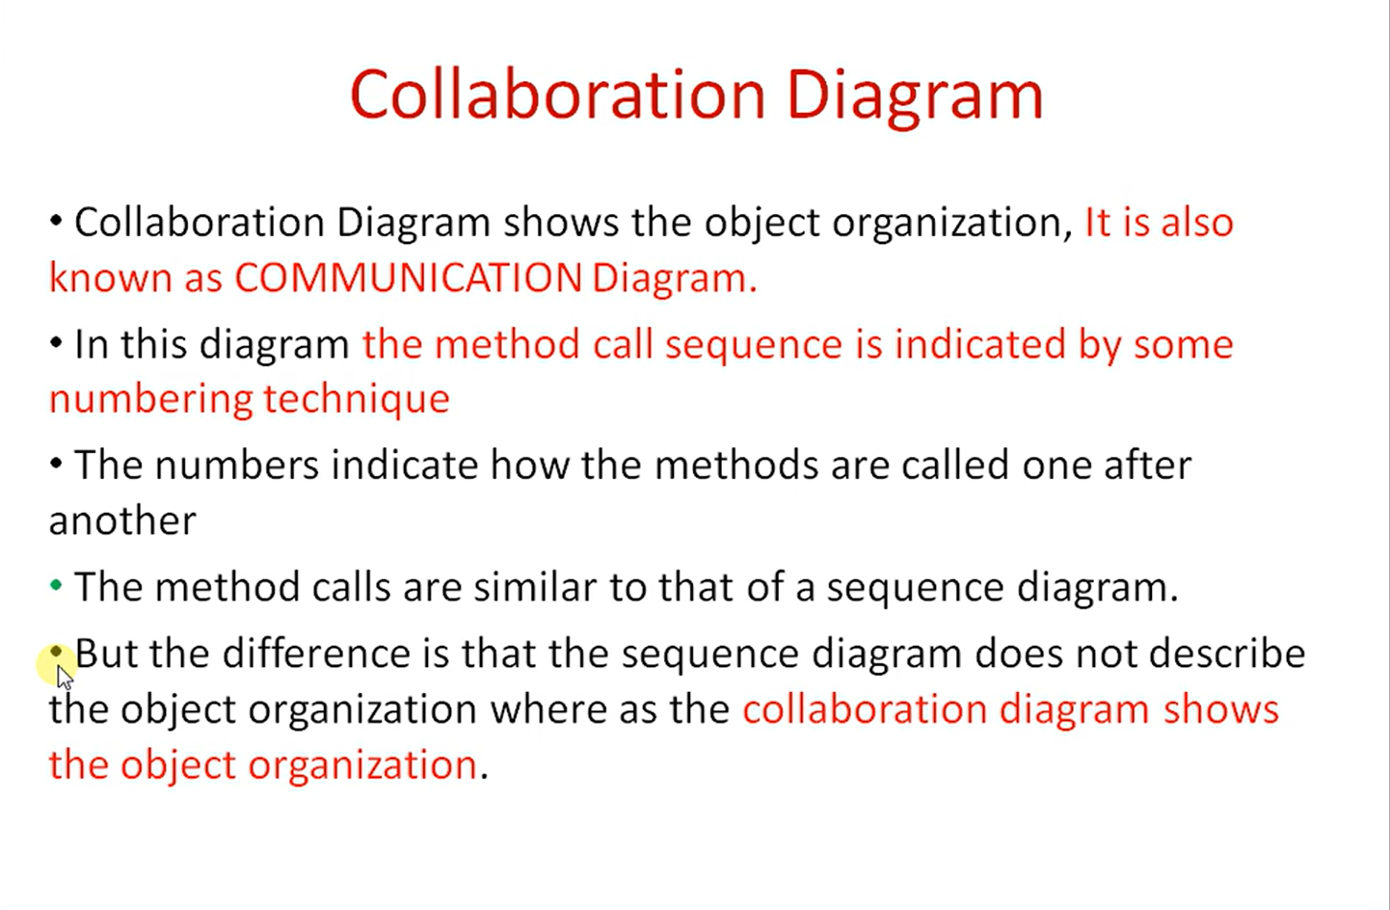

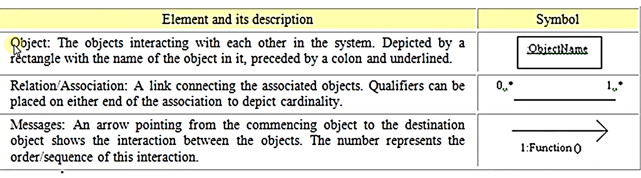

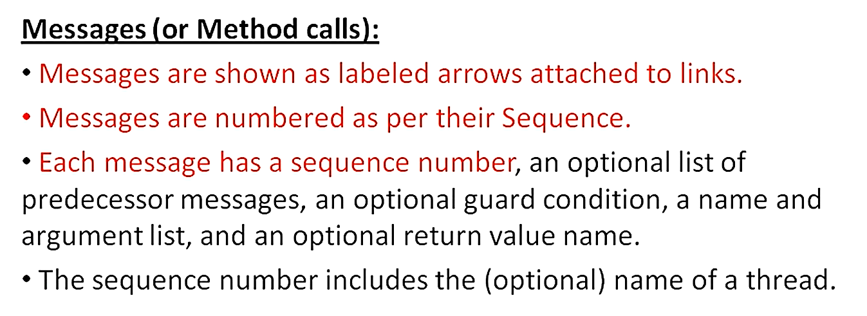

Here is the communication/ collaboration diagram for YouTube.

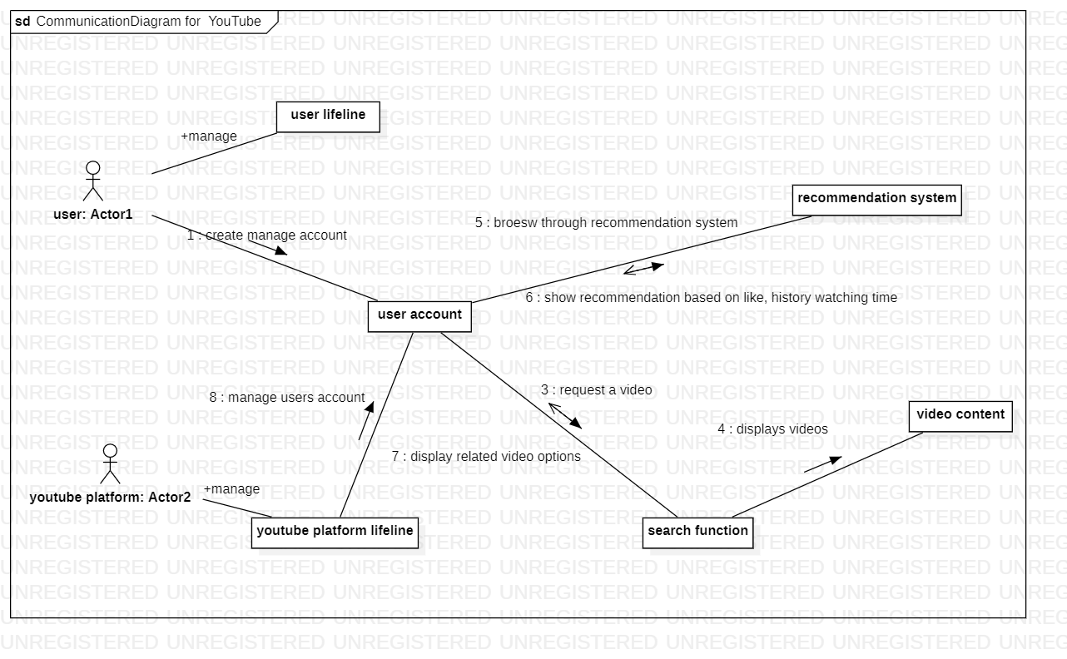

Overall, collaboration diagrams are useful tools for visualizing the interactions within a system and can be used to identify potential issues with the system's design or to communicate ideas to stakeholders.